Add-on Course

Topic- Applied Ethics

Academic session- 2022-23

Date: - September 2022

Duration: - 30 Hours

List of students Registered and completed the course

Sl,No | Name of students | Reg no. | Session | Signature of the students
01 | Fensi Mandal | 072278 | 2020-21 | 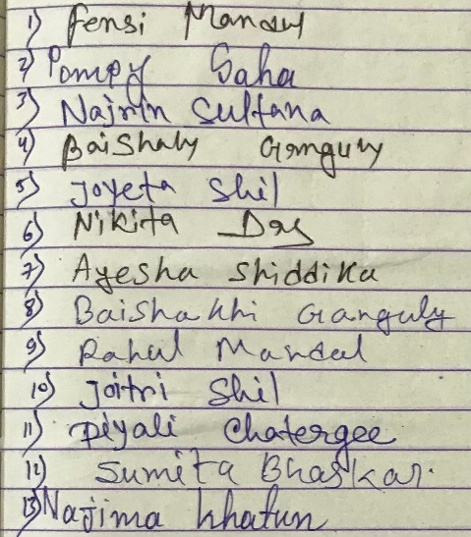
02 | Pompy Saha | 072374 | 2020-21
03 | Najrin Sultana | 072342 | 2020-21
04 | Baishaky Ganguly | 072268 | 2020-21
05 | Joyeta shil | 084959 | 2021-22
06 | Nikita Das | 072355 | 2020-21
07 | Ayesha Siddika | 081975 | 2020-21
08 | Baishakhi Ganguly | 072269 | 2020-21
09 | Rahul Mandal | 072172 | 2021-22
10 | Joitri Shil | 072294 | 2020-21
11 | Piyali Chaterjee | 084968 | 2021-22
12 | Sumita Bhaskar | 068301 | 2019-20
13 | Najima Khatun | 068365 | 2021-22

